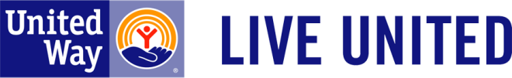
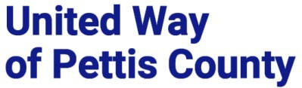

The United Way of Pettis County requires funded partners to submit quarterly reports and a final report. Funding is only distributed upon receipt of the reports. Reports will be submitted electronically from the UWPC funded partner portal.

The data will be entered according to the UWPC priority areas as outlined below:

Mental Health & Substance Abuse: Improving Access to Care, and Improving Health Literacy
Childhood Development: Improving 3rd grade reading levels, Improving Attendance, improving readiness to enter school
Hunger: Preventing Food Insecurity
Income Stability: Removing Financial Barriers to help individuals live a better quality of life.

Quarterly reports will include the following information:

- Project Name
- Number of Volunteers to support for the reporting quarter
- Project Number of Volunteer Hours to support for the reporting quarter
- How many FTEs to support project for the reporting quarter?
- List of collaborators for the reporting quarter?
- How many people were served (impacted) for the reporting quarter?
- Year to date expenditures according to budget submitted with application

End of the year report will include the following information:

- Project Name
- Number of Volunteers to support for the 4th Qtr.
- Project Number of Volunteer Hours to support for the 4th Qtr.
- How many FTEs to support project for the 4th Qtr.?
- List of collaborators for the 4th Qtr.?
- How many people were served (impacted) for the 4th Qtr.?
- Year to date expenditures according to budget submitted with application (this should be the cumulative total of Qtr. 1 – 4).

End of year report will also include a Narrative Response

- How do you define success of the project? Please reference your application (question 3 under Design and Execution)

- What changes did you anticipate?

- What changes actually happened?

- Please explain if there was a discrepancy in what you expected and what actually happened.

UWPC Reporting structure
Revised 05/03/2021 Page 1

